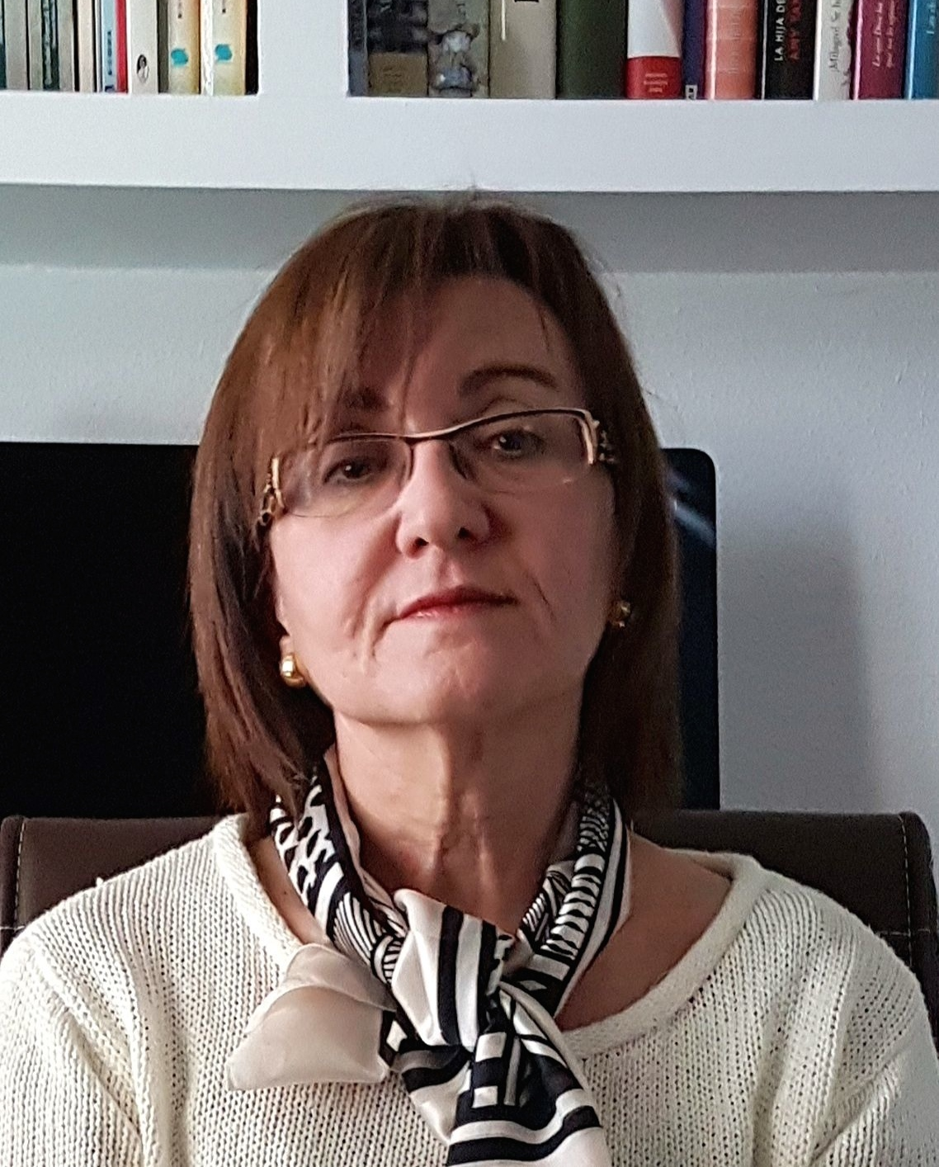

María Paz Sánchez has been a professor of Civil Law at the University of Cádiz since 2004. She graduated in Law in 1984 and obtained her law degree after defending her thesis in December 1985, earning her doctorate in 1989 (with an extraordinary doctorate award). She is the author of several monographs. These include: "Bases of Contractual Obligations in the Constitution" (Trivium, Madrid, 1991); "The Improperly Named Conscientious Objection to Medical Treatment" (Tirant Lo Blanch, Valencia, 2002); and "The Extinction of the Right to Compensatory Pension" (Comares, Granada, 2005). Animals as Agents and Victims of Damage, Editorial Bosch, Barcelona, ​​​​2008, (with J.M. Pérez Monguió and L. Ruíz), Damage and Game Species, Editorial Bosch, Barcelona, ​​​​2009 (with J.M. Pérez Monguió), Regime of Adoption of Agreements in Horizontal Property: Different Majorities and Procedures for Their Achievement, Aranzadi, 2016; Honor, Intimidated and Own Image, Editorial Juruá, 2017.
She has published around fifty articles in specialized journals and as many chapters in collective works on diverse civil law topics. She currently holds five recognized six-year research positions and five regional positions (the maximum number that can be obtained). She has directed the Consolidated Research Group "Person, Liberty, Law, Family and Property" (SEJ-327), part of the Andalusian Research Plan, since its creation (as "Contracts and Family Law") in 1999. She has been the IP of two national projects (The Common Framework of Reference Project (Books II and IV): Academic Commentary from Spanish Contract Law - coordinated project -, Ministry of Science and Innovation, from July 2009 to October 2012; and The Rights of Acquisition and Preemption - together with Professor Blandino Garrido -, Ministry of Science, Innovation and Universities, from 2018 to 2020). Furthermore, she has participated as a researcher in four national projects. The current one focuses on "Claudicant Properties" and has been funded by the Ministry of Science and Innovation for the period 2023-2026.
She has undertaken research stays at various foreign universities: Bologna, the Catholic University of Lyon, Coimbra, Minho, Brasov, Bangor, Messina, London, Cergy-Pontoise, as well as at the Institutes of Comparative Law of Lausanne and Florence, among others. She has held management positions as Vice Dean of the Faculty of Law at the University of Cádiz and Director of the Department of Private Law at the same university. From October 2009 to February 2014, she was a member of the Social and Legal Sciences Committee of the ANECA Faculty Evaluation Program, serving as secretary of the aforementioned Committee from February 2014 to February 2015. Since 2019, she has held the position of Inspector General of Services at the University of Cádiz. She served as the Law Department Coordinator for the 2019 and 2021 2020 Salvador de Madariaga and José Castillejo Mobility Programs.
ORCID: | 0000-0002-8644-1768

